

**University of Connecticut**

**2015 EERI Undergraduate Seismic Design Competition**

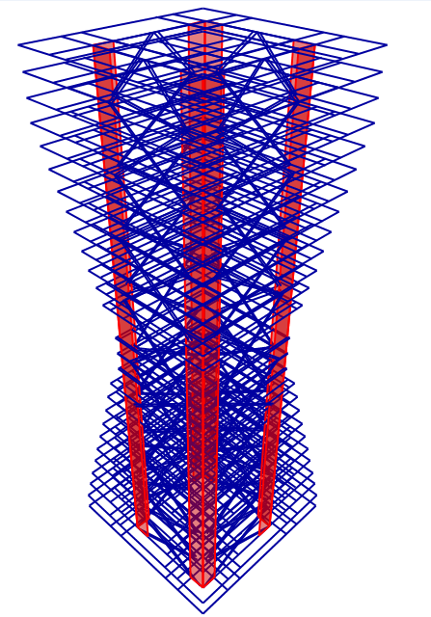

Team Captain:

Martin Ogwang

Team Members:

Samuel Turek

Nicole Prete

Claudia Maldonado

Lori Fomenko

Austin Cormier

**Project Description**

This proposal is for the construction of a 28-story building model made of balsa wood which conforms to both the EERI specifications and the architectural characteristics of the city of San Francisco. The objective of this project is to achieve economically efficient structural and architectural designs with acceptable seismic performance. This will be accomplished by researching San Franciscan architectural qualities, analyzing structural dynamic response, and performing material testing. Three major economic factors will be considered in the design including structure weight as a measure of cost, rentable area as a measure of revenue, and maximum drift and roof acceleration as a measure of seismic loss.

**Site Conditions & Seismic Hazard**

The San Francisco Bay Area is notorious for its sandy, muddy conditions. Based on the National Earthquake Hazards Reduction Program’s classification of soil types, the Young Bay Mud found here is soil type E. This soil type “Includes water-saturated mud and artificial soil”[1]. Soft soil, such as that found in the Bay Area, has resonant frequencies which amplify the excitation of the earthquake. In addition, San Francisco lies on the San Andreas and Hayward Faults.

Another issue which must be considered during design is liquefaction. Liquefaction occurs when the water in the pores of the soil is unable to diffuse through the soil medium fast enough to keep up with the earthquake acceleration, resulting in a suspension of soil particles in water. This liquefaction of the soil creates an instability in the underlying foundation, causing structures to sink into the ground.

**Structural System**

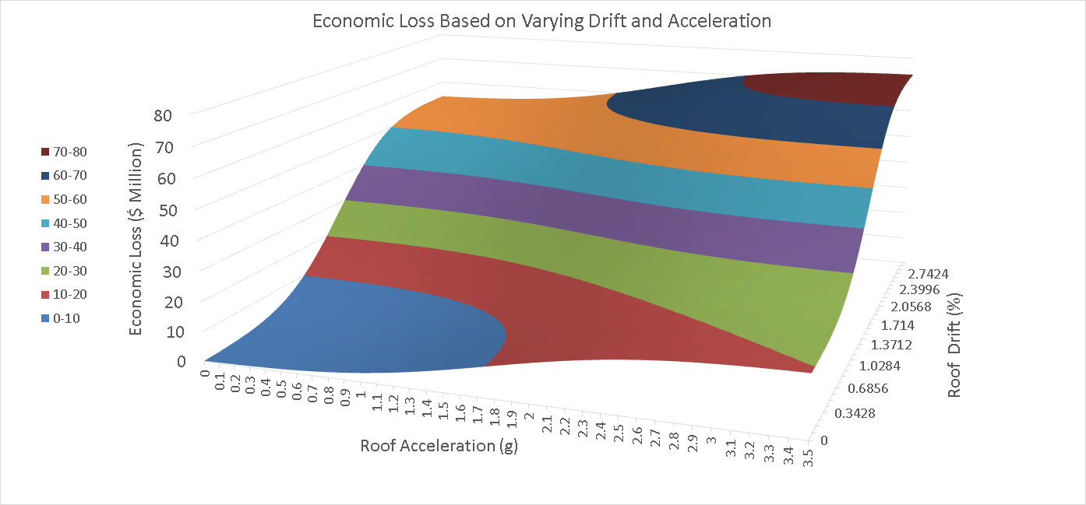From the initial calculations of the Final Annual Building Income (FABI), it was determined that the Annual Seismic Cost could be reduced by optimizing the building for smaller roof deflections. This was found by analyzing a scatter plot of Economic Loss based on the cumulative distribution functions for varying values of peak roof drift and peak roof acceleration. The determination that a building with smaller drift would be more beneficial in reducing economic loss was made using Figure 1.

**Figure 1: Annual Seismic Cost Calculations**

This can be accomplished by maximizing the flexural stiffness along the vertical axis of the building. This means that the in-plane moment of inertia must be augmented. The inclusion of a shear wall core as seen in Figure 2 located far from the central axis of the structure helps to achieve this goal. In addition, the cross braces add stiffness to the structure.

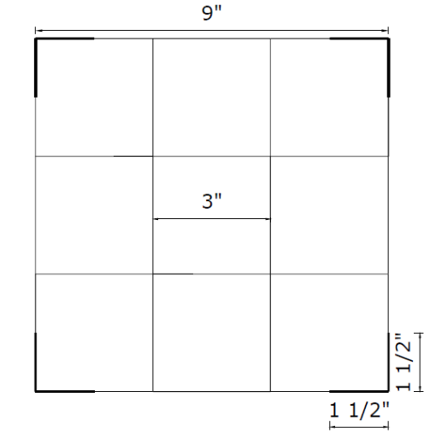Ultimately, it is desired that all the forces due to the inertia of the building be either dissipated or transmitted out of the structure through the base. This can be done through the use of shear walls, as well as the cross bracing which extend along the entire height of the building. The cross bracing also supports the added weights, and the inertial forces of the weights are transmitted through the cross braces into the shear wall and then into the base of the structure.

In order to control the motion of the structure, it is often advantageous to incorporate damping mechanisms within the structural design of a building. This can be accomplished with either traditional viscous dampers, friction dampers, or even with the inclusion of a tuned mass damper (TMD). The optimal tuned mass damping system includes some sort of additional damping mechanism applied to the tuned mass so that the motion of the TMD is controlled and energy can be dissipated efficiently. The concept of incorporating a pendulum style TMD coupled with viscous dampers is being considered. The entire TMD system would be placed close to the top floor of the structure to help mitigate the highest amount of structural vibrations.

**Figure 2: Floor Plan**

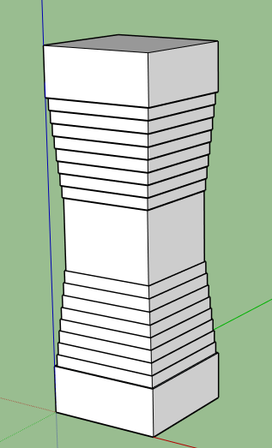**Architectural Description**

San Francisco architecture is a vibrant fusion of modern architecture with a Victorian style. The proposed high-rise building design is aimed at capturing the Victorian essence of downtown San Francisco as well as the modern skyline. The lower floors will blend in with the historical, urban street design with windows similar to the iconic San Francisco trolley cars. The middle to upper floors will fit into the unique San Francisco skyline by transitioning the lower design into a contemporary hourglass tower. This tower will be distinct in that as the floor plan tapers in size from ground level to the middle of the building and expands towards the top.

This hour glass shape, shown in Figure 3, will increase the available rentable area on the top floors of the building and provide a building as revolutionary as the companies that will be located there. This will allow for spectacular views of the city and bay from the top floors. The middle floors, including the restaurant on floor 15, will all have the same floor plan. The structural walls will be restricted to a central core of the building for maximized window area. The proposed tower will complement the existing skyline of San Francisco as well as the new Lumina I and Salesforce Towers which are currently being constructed.

**Figure 3: Building**

**Façade**

**Predicted Structural Behavior**

In order to predict the seismic performance of the structure, the following testing will be performed.

Material Properties: The appropriate types of balsa wood and glue will be selected based on research and investigated through small scale tests. For frame members, tensile, compressive, and bending tests will be conducted to determine material properties of the selected wood, as well as member capacities. For shear walls, bending test will be used to predict the shear and flexural behavior of each element. In addition, the tensile tests will be performed on a glued connection to optimize the stiffness of the connections.

Preliminary Design: A 3-dimensional analytical model of the structure will be created using SAP 2000. Shear walls will be modeled as shell elements, and beams and columns will be modeled as frame elements. For primary assessment of the structure and each of its elements, modal response spectrum analyses will be performed using the provided pseudo-acceleration spectrums.

Refined Analysis: The material properties obtained from the initial material tests will be incorporated in the analytical model. Then three time history analyses will be executed using the provided ground motion records to predict the performance of the structure. Necessary changes and refinements in size and arrangement of elements will be applied to achieve an optimal design.

Shake Table Test: The team has obtained permission to perform testing on the University Consortium for Instructional Shake Tables (UCIST) unidirectional shake table at the University of Connecticut. If the budget and timetable allow for construction of a second structure, the design team plans to build a full scale model and testing it under all three ground motions.

**Economic Considerations**

One of the goals of this year's design is to maximize the Annual Revenue of the building. In order to accomplish this, the maximum number of floors will be used. In order to keep within the 5000 square inch floor area limit, not all floors could have the maximum footprint. To maximize revenue, the floors worth the most, 1 and 2 as well as 25-28, were made the largest. The building then slopes in from both the top and the bottom as seen in Figure 3. This provides a total floor area of 4998 square feet and a revenue of $827,591. This high revenue combined with a low seismic cost should lead to a very successful building with a high Final Annual Building Income.

1. USGS (2012). "Soil Type and Shaking Hazard in the San Francisco Bay Area."